# COMP3500: Process Control (Part 2)

**Difficulty Level:** 🟊: >85%, 🟊🟊: 70-85%, 🟊🟊🟊: 55-70%, 🟊🟊🟊🟊: 40-55%, 🟊🟊🟊🟊🟊: < 40%

🟊🟊 **Exercise 5 (Plickers):** The context-switch time is OS overhead. The context-switch overhead depends on the following factors **except**. (1 Minute)

1. The complexity of the OS and PCB B. Open source operating systems
2. Multiple sets of registers per CPU D. Multiple contexts loaded at once.

**Exercise 6:** What are the two possible process states? (30 seconds)

**Exercise 7:** What are the five process states? What’s a difference between “ready” and “waiting”? (30 seconds)

**Exercise 8:** What are maintained in the ready, blocked, and event queues? (20 seconds)

(30 seconds)

**Exercise 9:** Can you propose a new state Process model with the suspend state? (1 Minute)

# COMP3500: Synchronization Part 1: Critical Section

**Exercise 1:** What is the problem with the following code? (1 minute plus 2-minute group discussion)

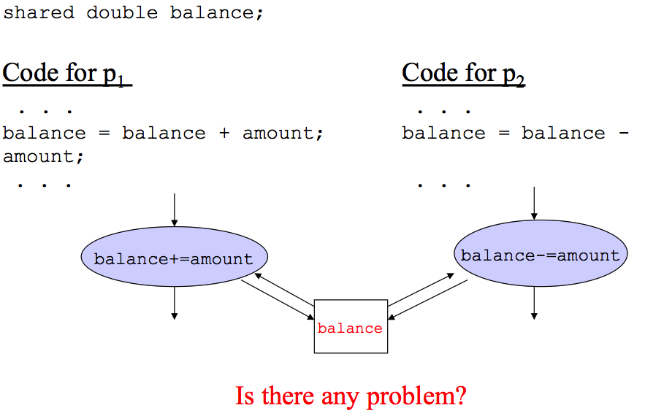

**Exercise 2:** Can you change the order of execution in the previous example to obtain another result? (1 minute)

**Exercise 3:** Can you propose an idea to solve the race condition problem? (1 minute)

**Exercise 4 (Plickers):** Which of the following requirements for mutual exclusion are difficult to understand? (1 minute)

1. Must be enforced. No deadlock or starvation
2. A process that halts must do so without interfering with other processes
3. A process must not be denied access to a critical section when there is no other process using it
4. No assumptions are made about relative process speeds or number of processes. A process remains inside its critical section for a finite time only